Microsoft Project Server and SharePoint 2010 Upgrade



CUSTOMER NAME

Quote and Statement of Work

1/15/2013

Presented by:

Advisicon Inc.

Tim Runcie, PMP, MCTS, MCP, PMP, MVP



# TABLE OF Contents

[1. Executive Summary 4](#_Toc346029674)

[2. Project Summary 4](#_Toc346029676)

[3. Project Phases 5](#_Toc346029678)

[4. Detailed Project Phase Breakdown 6](#_Toc346029680)

[5. Project Change Management 8](#_Toc346029684)

[7. Assumptions 9](#_Toc346029688)

[8. Out of Scope 9](#_Toc346029690)

[9. Travel Expenses 10](#_Toc346029692)

[10. Terms and Conditions 11](#_Toc346029694)

[11. COMPANY NAME Acceptance 12](#_Toc346029695)

[12. Advisicon’s Commitment 13](#_Toc346029696)

[13. Possible Future Scope 13](#_Toc346029697)

[14. Advisicon: Experience & Capabilities 14](#_Toc346029698)

[15. Advisicon Credentials & Accredidations: 15](#_Toc346029699)

[16. Advisicon consulting / training approach: 16](#_Toc346029700)

# 1. Executive Summary

COMPANY NAME (hereafter referred to as ACRONYM) is contemplating the option to upgrade to Microsoft’s Project Server 2010 Solution to enhance their Project and Program management capabilities.

Advisicon will meet with COMPANY NAME primary stakeholders and associates for this project to gather, analyze, and document the essential requirements and business drivers for the upgrade. This phase will allow Advisicon to intelligently design and plan the implementation, while at the same time providing the necessary information to best configure this tool set for COMPANY NAME.

This Microsoft Project Server 2010 Solution is intended to help COMPANY NAME increase efficiency and visibility. From portfolio and enterprise level reports and services, down to assignment collaboration and notifications services; every role in the COMPANY NAME project organization will have a tool to use.

# 2. Project Summary

The scope and criteria of the planned COMPANY NAME MS Project Server 2010 upgrade project includes:

* Architecture/Design Recommendations – Project Server HW requirements; review of SharePoint 2010 install platform architecture
* Upgrade of Enterprise MS Project Server 2007 Installation (PWA & Project Pro clients) to Project Server 2010 to include data migration/conversion:

1. All database data
2. All current state Reporting objects (SSRS, SQL Server Analysis Services)
3. All User Security and current configuration not modified in upgrade

* Assess and configure new module functionality in PS2010 (BI Reporting, Demand Management, Portfolio Management, etc.)
* Training: (Includes training materials)
  1. Provide training for IT System Administrators
  2. Provide training for Project Managers
  3. Provide training for Team Members (End Users)
  4. for Administrator and End-User level training (PWA, Project Professional clients) to include internal HW Support Training and (Vikas Thakur’ as the ENG instance IT System Admin for ENG instance.)
* This implementation will be an extended rollout based on Team Availability through end of this year (2012) or the first part of January 2013. Preferably sooner, but based upon LSI Resource Availability.

# 3. Project phases

Advisicon will implement COMPANY NAME Project Server system in a phased approach. Phases 2–6 will be greatly impacted by facts revealed during the Requirements Gathering process of Phase 1.



This Statement of Work documents the scope of this project at this time.

The deliverables and services described in this SOW are NOT fixed-price deliverables; the estimates provided above are based on Advisicon’s experience with these types of upgrades. Once we have completed Phase 1: Requirements and Specifications Gathering, we will be able to validate our understanding of the remaining phases of this engagement.

Advisicon will invoice only for the actual hours worked on the activities and deliverables described in this SOW and those approved through the change management process that COMPANY NAME and Advisicon will develop and agree upon as defined for the engagement.

# 4. Detailed Project phase breakdown



# 4. Detailed Project phase breakdown - Continued



# 5. Project Change management

COMPANY NAME and Advisicon will develop and agree on a shared process for managing changes during Phases 2-6 of this project. COMPANY NAME and Advisicon agree to work together; to monitor and manage changes and refinements to the scope, design, and work of this project. This document defines the scope of this project, at this time, and provides the basis on which COMPANY NAME and Advisicon will manage the scope and changes in the course of this project.

# 6. Risks

The following risk factors need to be weighed and managed to realize the full value of the proposed work.

1. **COMPANY NAME User Adoption:** COMPANY NAME has developed its own Production System for many management functions. Utilizing a process-driven system like Project Server will require user training and consistent usage. If COMPANY NAME users do not use Project Server consistently, the value of the system and success of the implementation will be compromised. Given Cultural factors will need to be considered and management will need to support development and implementation of a plan to ensure user adoption.
2. **Workload Impacts:** Implementing a new PPM system takes time and requires user training. COMPANY NAME management will need to take steps to facilitate the organizational change, so personnel will be available and committed to user training and the new workload associated with using Project Server and their project assignment workloads.
3. **Timing:** There may be times when other work competes or conflicts with the work in this SOW, which could delay the work. The timing of work will need to be coordinated by both Advisicon and COMPANY NAME to meet the needs and resource availability of both.

# 7. Assumptions

This proposed SOW is based on the following assumptions:

1. This solution is a self-owned solution. This implementation does not include Advisicon hosting COMPANY NAME instance of Project Server 2010. The infrastructure maintenance and support is managed by COMPANY NAME, their IT staff and chosen vendors.
2. The current IT infrastructure at COMPANY NAME can support the solution, or COMPANY NAME will be willing to support infrastructure enhancement to support the solution.
3. Microsoft Project Server training will be conducted either on-site/off-site within COMPANY NAME Project Server environment.
4. The performance of the work described in this SOW and the schedule for delivering it is dependent upon adequate COMPANY NAME resources being available for the planning, training and deployment of the solution.
5. The customer will be contributing to the project < Tye Etc>

# 8. Out of Scope

The following items are outside the scope of this SOW:

1. COMPANY NAME will be responsible for procurement of any necessary required hardware, software, and corresponding licensing, directly with COMPANY NAME preferred vendors
2. Administrative support of COMPANY NAME PPM and other systems
3. Subsequent stages of adopting additional PPM 2010 capabilities outside the scope of this proposal.
4. Any customization of additional templates, custom coding, custom reports, custom forms, custom views, and custom workflows are not included in this proposal

# 9. Travel expenses

If travel is required the following guidelines will come into effect:

1. Driving mileage to be reimbursed at $0.56/ mile.
2. Per diem $75/day
3. Other expenses to be reimbursed at actual cost to Advisicon; receipts to accompany invoices.
4. Additional documentation and analysis outside of work detailed within this proposal shall be addressed through separate written SOWs and subsequent associated purchase orders.

# 10. Terms and conditions

Please review and initial the terms listed below. Following the signed Statement of Work a NDA and all COMPANY NAME billing information will be collected.

1. Service Period - The Service Period of this estimate shall commence upon approval using a Purchase Order. This estimate dated Click here to enter a date., is valid for approximately 30 days (expires Click here to enter a date.).

\_\_\_\_\_\_\_\_ [initial]

1. A credit approval may be needed to set up payment terms. Otherwise, payment in full at the start may be required.

\_\_\_\_\_\_\_\_ [initial]

1. Payment - This engagement involves a Choose an item.that is based on the Project Phases table. Invoices will be submitted in two stages:
   1. 50% upfront to kick-off project (~$xx,xxx)
   2. Choose an item.

All expenses and training materials will be invoiced within two weeks of occurrences

Any additional costs/deliverables will be managed through a change control process and payment will only be rendered for those costs/deliverables that have been authorized by COMPANY CONTACT.

\_\_\_\_\_\_\_\_ [initial]

1. As compensation for fulfillment of Advisicon’s obligations outlined in this Statement of Work and detailed in a separate invoice, COMPANY NAME shall compensate Advisicon for consulting services and training.

\_\_\_\_\_\_\_\_ [initial]

1. Advisicon invoices bi-weekly.

\_\_\_\_\_\_\_\_ [initial]

1. COMPANY NAME agrees to remit payment for invoiced services Choose an item. with expected payment of Choose an item. days with a 1.5% penalty for late payment. IN WITNESS WHEREOF, the parties hereby execute this proposal as of the date set forth below.

\_\_\_\_\_\_\_\_ [initial]

1. Upon review and agreement to these conditions and payment terms, Advisicon will issue a Letter of Engagement and a Customer Purchase Order will be issued to Advisicon to kick off the project.

\_\_\_\_\_\_\_\_ [initial]

1. Invoices shall be considered accepted by COMPANY NAME as a correct reflection of services rendered unless COMPANY NAME notifies Advisicon of a billing dispute in writing within three (3) business days upon receipt of the invoice.

\_\_\_\_\_\_\_\_ [initial]

1. COMPANY NAME acknowledges and agrees that initials on this page constitutes receipt acknowledgment of this Statement of Work, and agrees to be bound herein as described within the contents of this Statement of Work.

\_\_\_\_\_\_\_\_ [initial]

1. Please send any questions to Tim Runcie - tim.runcie@advisicon.com/(866) 362-3847

In the event of suit over nonpayment, the prevailing party is entitled to its costs, expenses, and reasonable attorney fees’ (whether incurred at trial, on appeal, or otherwise) incurred in resolving or settling the dispute, in addition to all other damages or awards to which that party may be entitled.

This Agreement is governed by, and must be construed and enforced in accordance with, the laws of the State of Washington, excluding principles of conflict of law. For all disputes relating to this Agreement, each party consents to the jurisdiction of the courts of the State of Washington and agrees that those courts have personal jurisdiction over each party. Venue for all disputes must be in Clark County, Washington

# 11. Acceptance

Please initial the Terms and Conditions where indicated and sign below to authorize the work described in this Statement of Work (SOW).

This signed authorization indicates that COMPANY NAME approves this SOW for Advisicon to perform the work described in this document and that COMPANY NAME will pay for the services described herein.

NAME Date

COMPANY NAME

NAME Date

COMPANY NAME

# 12. Advisicon’s Commitment

Thank you for this opportunity to help COMPANY NAME achieve its project, program, and portfolio management objectives. Advisicon is committed to delivering the best in professional consulting and training services. Our goal is to satisfy your business needs, exceed expectations, and earn your confidence for delivering future services.

Advisicon looks forward to assisting COMPANY NAME.

Presented by

*Tim Runcie*

Tim Runcie

Advisicon

Office 360-314-6702  |  Email [Tim.Runcie@Advisicon.com](mailto:Tim.Runcie@Advisicon.com)

# 13. Possible Future Scope

As COMPANY NAME considers how to move toward a more disciplined and systematic approach to Demand Management (capacity planning) and Portfolio Management, Advisicon stands ready to help provide guidance through the process, as well as with other SharePoint©, project and program management consulting services.

* Identify a prioritized list of the future Project Server development needs for custom fields, views, reports, workflows and other features that COMPANY NAME will need.

# 14. Reference Accounts

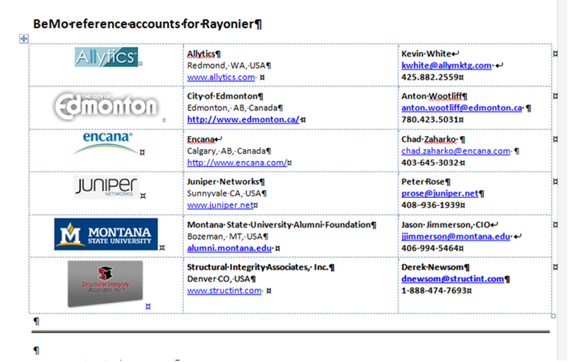

# 15. Advisicon: Experience & Capabilities

Advisicon delivers strategic project control solutions using advanced project and portfolio management methodologies, custom application development and consultative training.

Our clients throughout North America and Latin America have realized quantifiable results through our unique approach of combining knowledge transfer, optimization and sustainability of processes and technology while increasing stakeholder competencies.

**Consulting and Training Services**

* Lifecycle management; organizational change and productivity solutions with integration consulting
* Project and work management assessments and optimization consulting
* Microsoft**®** Project, Project Server, and Portfolio Server solution and integration consulting (all versions)
* Microsoft**®** SharePoint solution and integration consulting (all versions)
* Dynamic project scheduling, program administration and staffing services and consulting
* Custom Application Development (complex databases, integrations, reports, workflows and dash-views)

[](https://intranet.advisicon.com:447/dept/salesandmarketing/Logos/Gold_Silver%20PPM%20White.png) **Microsoft Gold Certified Partner**

Advisicon is one of only a few Microsoft Gold Certified Enterprise Project Management Partner. We are uniquely qualified to help organizations that are using or evaluating using:

* Microsoft Office Project and Microsoft Office Project Server
* Microsoft Office Project Portfolio Server
* Windows SharePoint Services (WSS) and Microsoft Office SharePoint Server (MOSS)

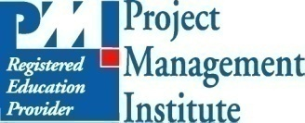**Project Management Institute Global Registered Education Provider (REP)**

Advisicon is a Global Registered Education Provider (REP) of the Project Management Institute (PMI). Our clients have confidence knowing that they have chosen an organization that is qualified to provide the highest level of project management training, and the convenience of receiving Professional Development Units (PDUs).

# 16. Advisicon Credentials & Accredidations

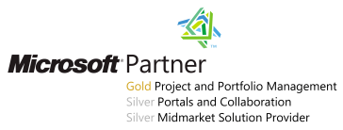Advisicon is also a Gold Project and Portfolio Management partner with Microsoft – the highest partner level achievable, as well as a Silver partner in Portals and Collaboration. This strong combination of competencies illustrates Advisicon’s combined knowledge of the full PPM platform and EPM solution. This allows Advisicon access to Microsoft support not available to other partners and affiliates of Microsoft.

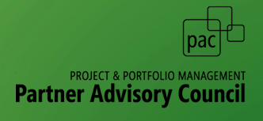Advisicon serves on the Partner Advisory Council (PAC) working with Microsoft Product Team on each release of their PPM technologies before they are released. Currently we will understand how and where Microsoft is going and can help ensure Waggoner Edstrom will not do something in Project Server that will limit or prevent them from scaling up to newer versions and features as they become available.



Advisicon is also used by Microsoft as V-TSP’s (Virtual Technical Specialists.). This role allows only the best industry experts to server as technical and customer support representing and answering solution and business needs questions for PPM technologies across North America.

In addition, Advisicon regularly contributes to the community of practice with writing whitepapers, contributing to blogs and monitoring forums to assist practitioners in the use of the Microsoft Project Server solution. Currently Advisicon has written and produced videos, training materials, flow charts that answer and are used by Microsoft on TechNet to help guide customers world-wide to levering Project Server to the its best and optimized use for organizations.

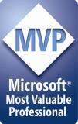

Advisicon’s staff holds top industry certifications which require proving knowledge levels through exams and continuing education. These certifications include technological topics, project management competencies, as well as Microsoft’s Most Valuable Professions (MVP) – an elite hand-picked group of top experts. There are less than 40 Microsoft Project MVPs in the world.

In short, we are experts in technology that optimizes and reinforces Project, Program and Portfolio management. We won’t hesitate to recommend not jumping to a tool if the culture or maturity level of the organization isn’t ready for it.

# 17. Advisicon consulting / training approach

**Advisicon’s approach is based on three tenets:** ***Knowledge Transfer / Optimization / Sustained Results***

We understand that there is a maturity and scalability for building a Project Management culture that you can’t achieve by just installing technology. This needs to be blended and optimized. That is why we focus on knowledge transfer designed to embed a long term understanding and ability to grow technology as a solution.

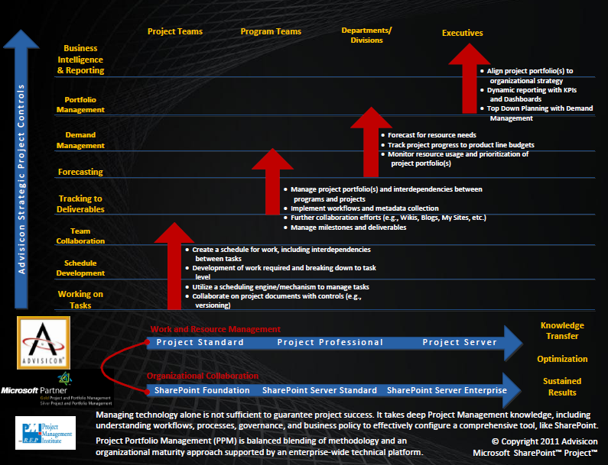

**Project Server**

Gerber Team

ROI

**SharePoint/Project Pro**

Figure : Advisicon Strategic Project Controls

***Knowledge Transfer***

Advisicon consultants first learn the key business drivers to any successful solution. Simultaneously, Advisicon consultants teach clients to internalize and standardize project management best practices and use of technology. Clients receive task-specific coaching, in-depth process development, customized project management methodology and supervised training with the technology.

**Knowledge Transfer** provides for synchronized learning. Advisicon will gain knowledge of Gerber Life Insurance s experiences while imparting best practices learned from our deep knowledge base. This information exchange facilitates internalizing and standardizing best practices and use of the technology.

***Optimization***

Advisicon consultants integrate project management best practices and project management technologies to fit each client's organizational structure, strategy, goals and culture. This can include integration or building out the technology to optimize and automate manual processes identified in you the customers project or product lifecycle.

**Optimization** will identify situations for emphasizing performance improvement within the new system.

***Sustained Results***

Through Advisicon's phased approach, our clients are able to adopt and implement strategic project management improvements one step at a time, growing from one level of project management maturity to the next. Through this process of optimization and knowledge transfer, Advisicon clients realize sustained results and scalable business options.

**Sustained results** realized through user adoption and technical acceptance through the organization’s culture. Training recommendations will be provided to guarantee development of internal SME’s to allow Gerber Life Insuranceto maintain the new system.

Figure : Advisicon Tenants of Culture & Technology Implementation

**Methodology / Project Management Training Materials, Tools & Flowcharts**

The flowcharts and electronic tools accompany the Methodology training. These include PM Lifecycle best practices and Requirements /Risk Management best practices. It also includes PM electronic tools created in Office Products (Excel, Access and MS Word) valued at $1,500, that project managers find rapidly expedites their work activities.

|  |  |  |
| --- | --- | --- |
| Requirements Elicitation Flowchart sm.png | PM Flowchart | |
|  | | **Stakeholder Support Analyzer**  [https://store.advisicon.com/secure/images/products/130.jpg](http://store.advisicon.com/Project-Management-Tools/Stakeholder-Support-Analyzer-p17.html) |
| **Responsibility and Assignment Matrix**  [https://store.advisicon.com/secure/images/products/202.gif](http://store.advisicon.com/Project-Management-Tools/Simplified-RACI-Chart-p46.html) | **Risk Analyzer**  [https://store.advisicon.com/secure/images/products/132.jpg](http://store.advisicon.com/Project-Management-Tools/Risk-Analyzer-p18.html) | |

This is a small sampling of the tools/templates that accompany the training and consulting we do. The flowcharts are printed on 11” x 17” for the training classes to assist with visualization and tracking for the students of where they are at in a Project Lifecycle and what the next best steps are.

**Microsoft® Office Project Server, Project Professional, SharePoint and Business Intelligence Training:**

Advisicon has been authoring teaching and consulting in MS Project Server and MS Project Desktop since 1994. Below are the books that we will be using for this training that we use in our classes and recommend for this implementation.

|  |  |
| --- | --- |
| Microsoft Office Project Server Administrator Cover | [**Microsoft® Office Project Server 2010 / Administrator**](http://store.advisicon.com/Classes-and-Events/Microsoft-Project-Server-Administrator-p39.html) Learn how to configure, customize, administer and support Microsoft® Office Project Server 2010. Administrators will learn how to configure, customize and support Microsoft® Office Project Server. This course trains participants to set up and support enterprise‐wide project management standards, templates, resource pools, custom fields, management metrics and reporting, as well as how to manage Project Web Access. |
| Microsoft Office Project Server Project Manager Cover | [**Microsoft® Office Project Server 2010 / Project Manager**](http://store.advisicon.com/Classes-and-Events/Microsoft-Project-Server-Administrator-p40.html) Learn how to build, publish, and manage project schedules, issues, risks, deliverables, resources, and documents across an enterprise with Microsoft® Office Project Server 2010. Project Managers will learn to build, track and manage project schedules with Microsoft® Office Project Professional and publish them to Project Server, and how to track, analyze, and report on projects through Project Web Access. |
| Microsoft Office Project Server Team Member Cover | [**Microsoft® Office Project Server 2010 / Team Member**](http://store.advisicon.com/Classes-and-Events/Microsoft-Project-Server-Administrator-p41.html) Learn how use Microsoft® Office Project Server 2010 to contribute to projects across an enterprise. This course trains participants how to update and manage project tasks, enter and report on risks, issues, documents and new tasks through Project Web Access. |

**Optional Training that Customers Normally Request:**

These training books and classes are not included in the above estimates, but in most projects server implementations, the customer’s request these additional follow-on training to help them better grow and use SharePoint along with the Business Intelligence reporting options that come with Project Server, SharePoint and SQL Server.

|  |  |
| --- | --- |
|  | **Microsoft Business Intelligence: Building Executive Dashboards with SharePoint 2010** This course trains participants with an introduction to creating BI solutions using the Microsoft suite of tools. It has an emphasis on Excel Services, PowerPivot, PerformancePoint, and SharePoint.  Tutorials walk you through how to go about creating multifaceted BI dashboards, including KPIs, Scorecards, PivotTables, and Graphs.  This class also focuses on designing and building Data Warehouses, including a simple walkthrough for creating a SSAS cube, which has a key role in all SharePoint Business Intelligence Reporting |
| **SharePoint_Ready To Print_4th ed_072409** | **SharePoint for Effective Project Management**  Learn to use Microsoft® SharePoint to manage project team collaboration on projects.  This course teaches participants how to design, create and customize SharePoint sites and to use SharePoint to collaborate, share documents, communicate and coordinate activities and projects.  It is ideal for Team members to Site Administrators who want to maximize the use of SharePoint and understand how to leverage this for Projects and Team collaboration. | |

**Process Mapping & Gap Assessment:**

Mapping work and project lifecycles will help us identify any opportunities to create workflows in Project/SharePoint that can send email alerts and automate the now manual communications and report building and tracking.

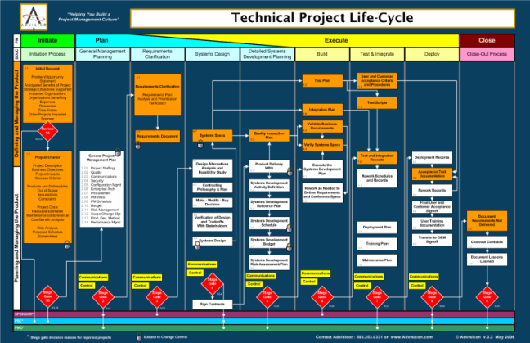

Advisicon will establish Risk and Stakeholder Gap Analysis and mitigation steps/recommendations for building a roadmap for improving the PM maturity growth in your organization.

[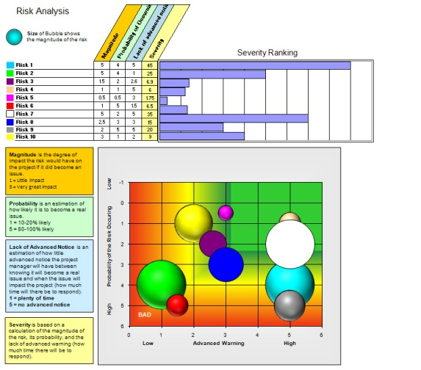](http://store.advisicon.com/Project-Management-Tools/Risk-Analyzer-p18.html)

[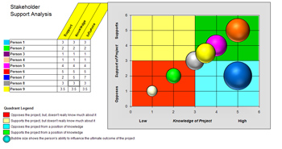](http://store.advisicon.com/Project-Management-Tools/Stakeholder-Support-Analyzer-p17.html)

Creating an analysis of technical steps, options or solutions that will best fit and integrating automation and optimization alongside your new or reinforced processes.

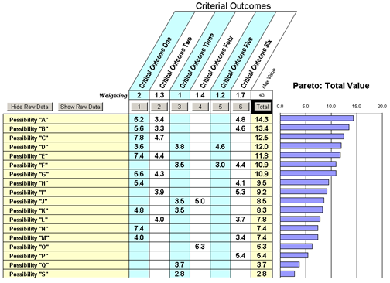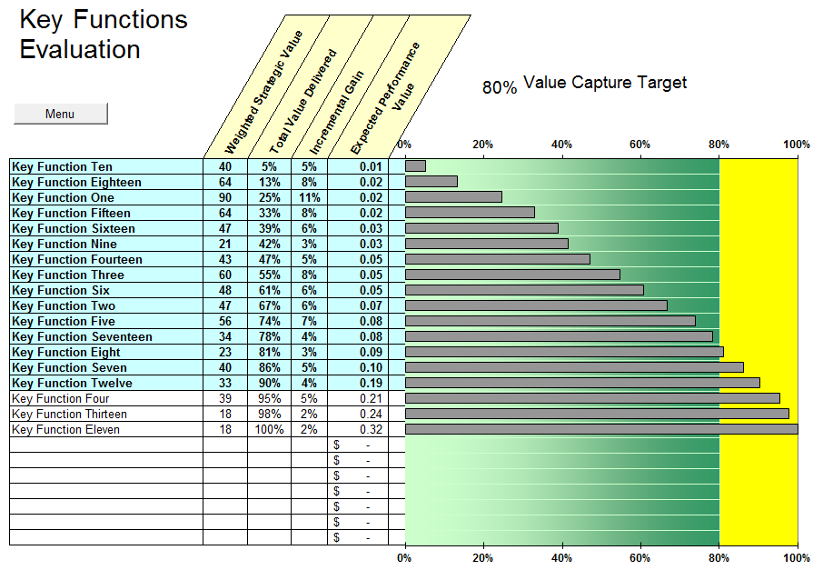

**Automate Task Visibility & Communications:**

The ability for team members to get e-mail alerts as well as to have a personalized home page alerting them to what is coming, assigned or needing addressed. Advisicon will be assisting with templates, schedules and best practices to eliminate the overhead of effort tracking details, while maximizing the benefits of good processes and procedures combined with project and task reporting.

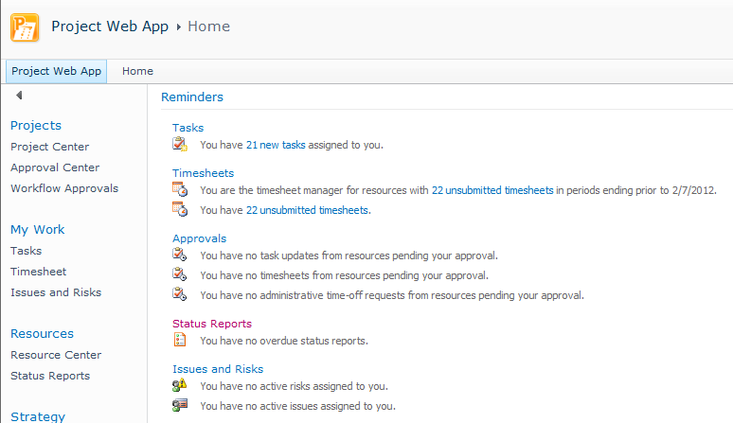

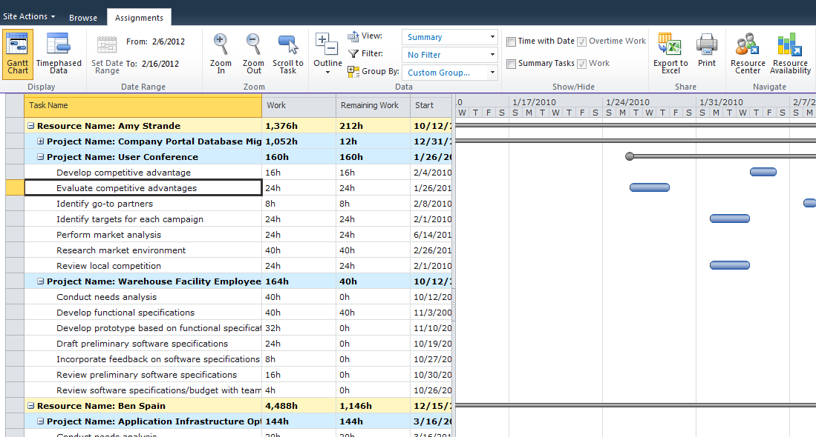

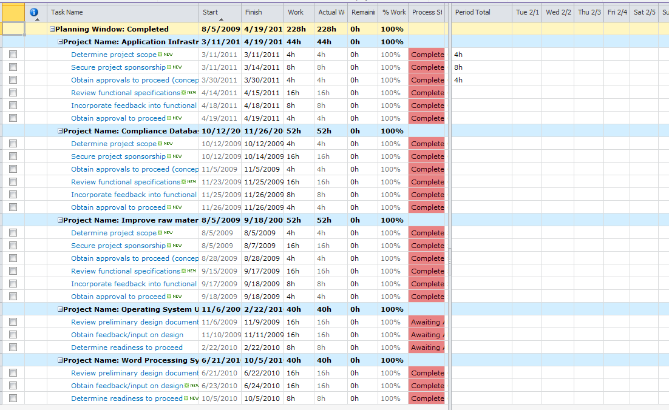

**Existing Work Portfolio Management:**

Advisicon will help you build key indicators and automated alerts so that you can see Project to Portfolio visibility and drill into any potential issues by looking at indicators versus trying to manage everything or look at all moving parts.

From Portfolio or Program view as seen here

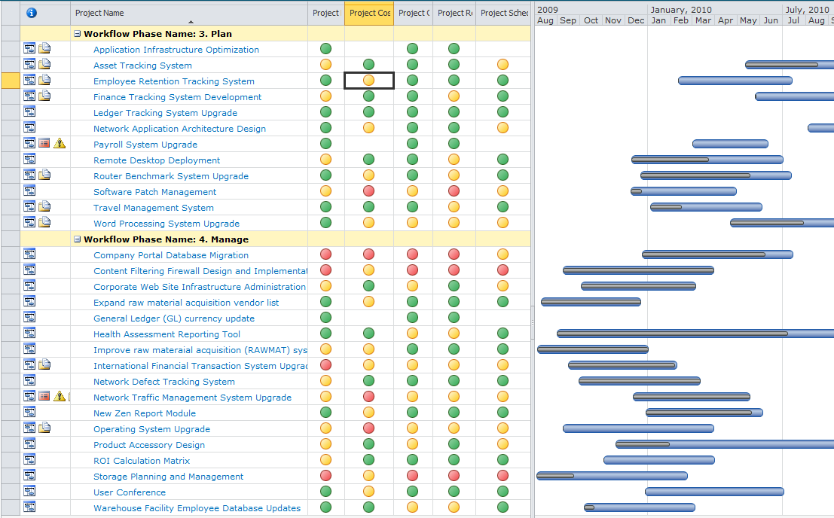

To drill directly into a task detail view as seen here.

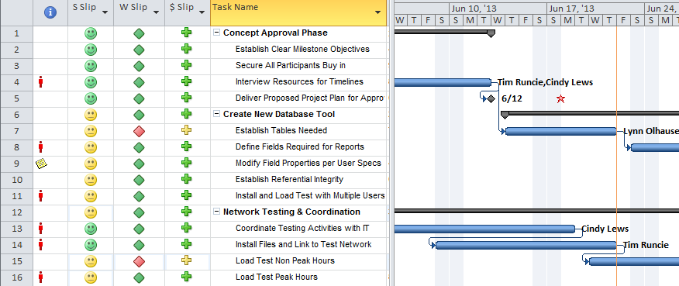

**Demand Management & Resource Capacity & Forecasting:**

Being able to map, track work by time (called Time-Phased) is a key part of having visibility to work, tasks, and costs over any period of time. This can only be accomplished with standardized and integrated schedules connect to a single resource pool. Advisicon will help you leverage Project and or Project Server to maximize the ability to see, forecast and make strategic decisions based upon

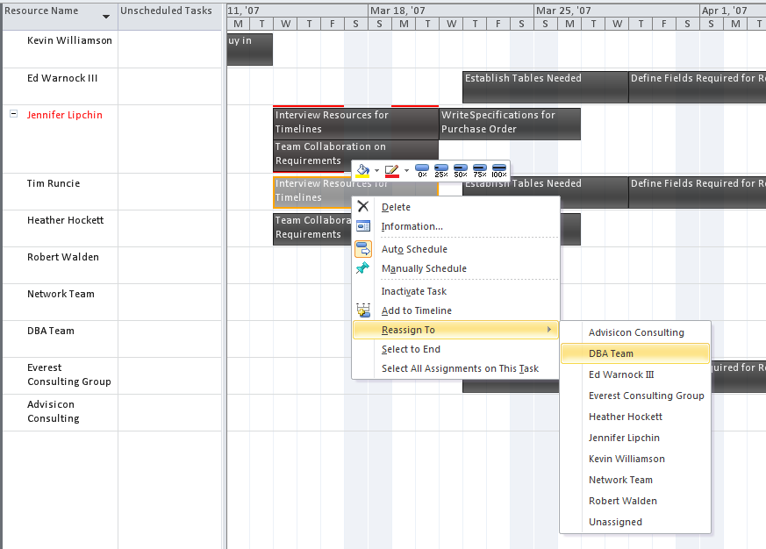

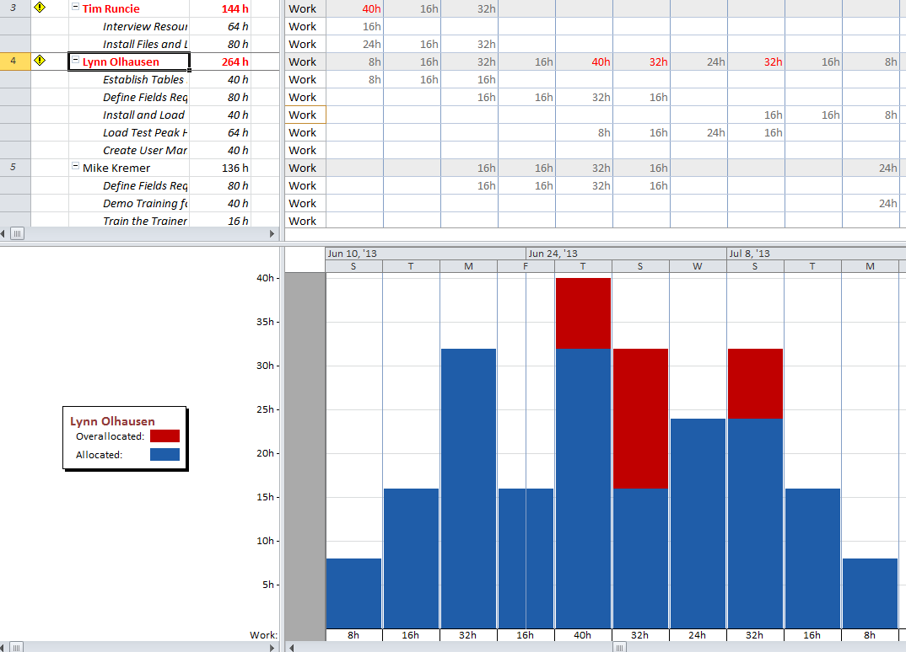

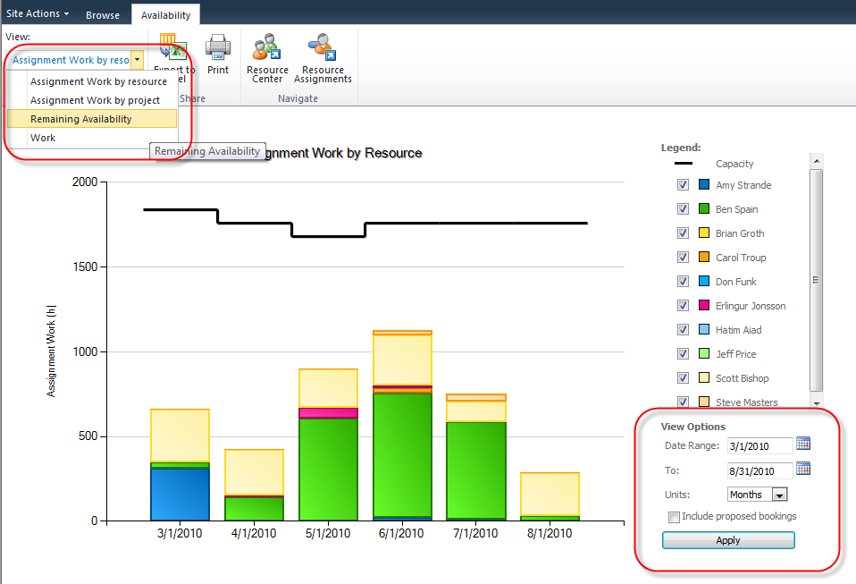

**New Work Portfolio Management:**

Advisicon will assist you in leveraging the future incoming proposals and establishing the strongest case for ensuring the projects started, delayed or cancelled will meet the business goals and direction of the organization. This essentially provides the ability to prioritize and do true portfolio management.

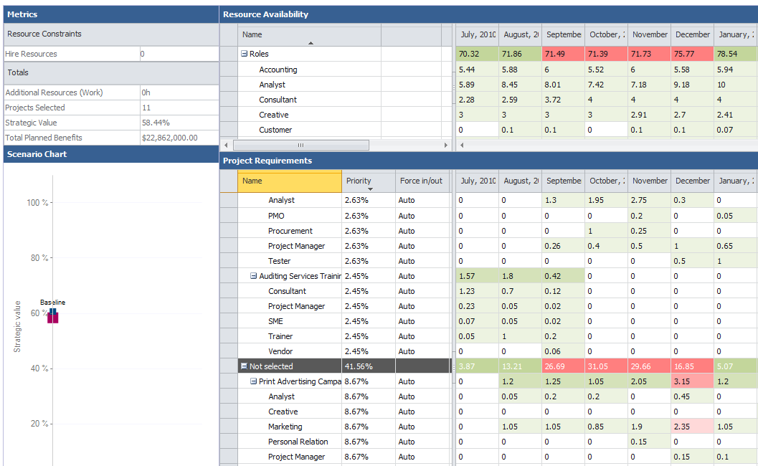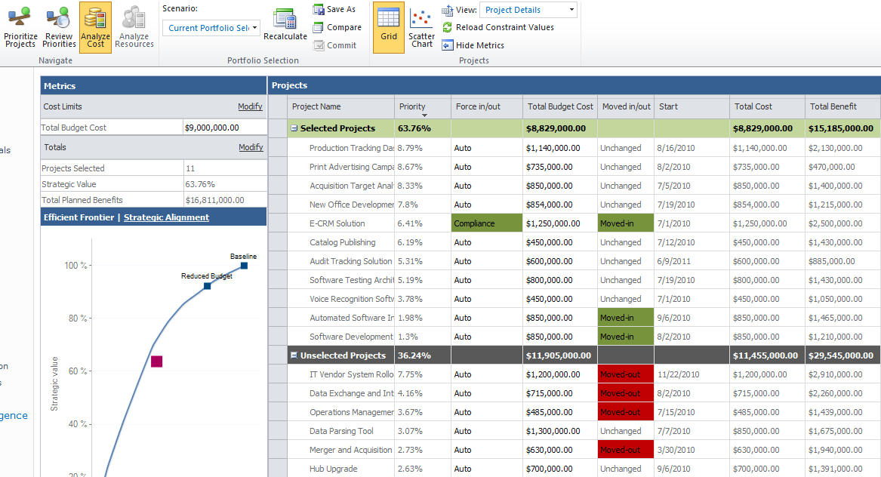

**Automation & Optimizing/Automating PM Lifecycle Workflows:**

Advisicon can help build visual workflows or to take PM Lifecycle processes and stage gates and create visual reporting and tracking alongside of the Project Information. This example below is on a SharePoint Project Workspace and the information is data driven from Project server as the proposed project moves through it’s stages and phases with e-mail and electronic alerts and the ability for people/stakeholders to see what is coming or to review, approve or reject a task or project request to move forward.

This creates a visual timeline and checklist that ensures good quality control on work and projects through their lifecycle.

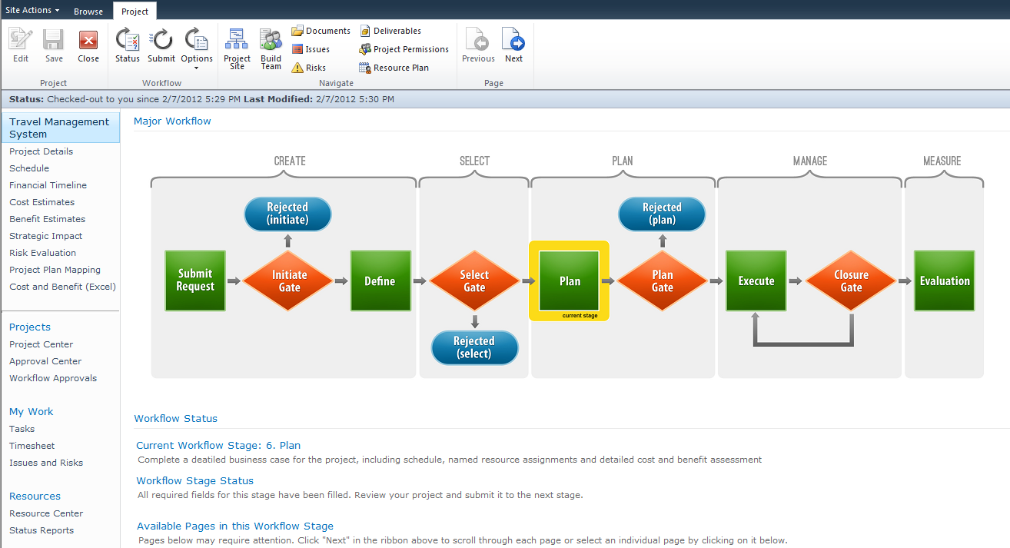

**Tracking, Reporting and Project Trend Analysis & Business Intelligence:**

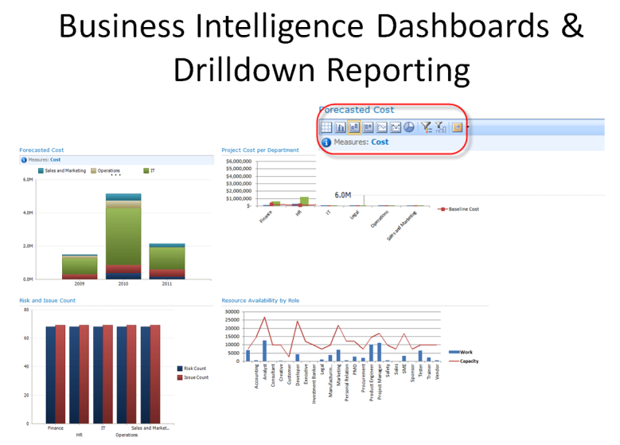Establishing a common reporting repository for a Team member all the way up to the PMO or organization is very straight forward and something that we ensure that every organization that works with Project and Project Sever / SharePoint helps establish and leverages.

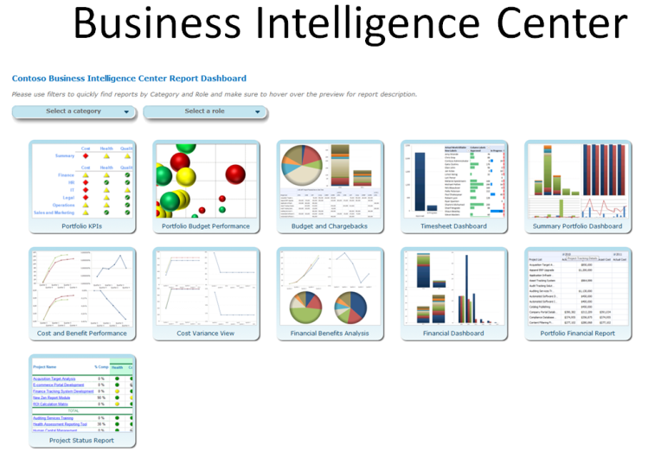

Continue mapping and reporting information and if necessary, immediately drill down into the report and see the details of any element, all without having to build a new report.

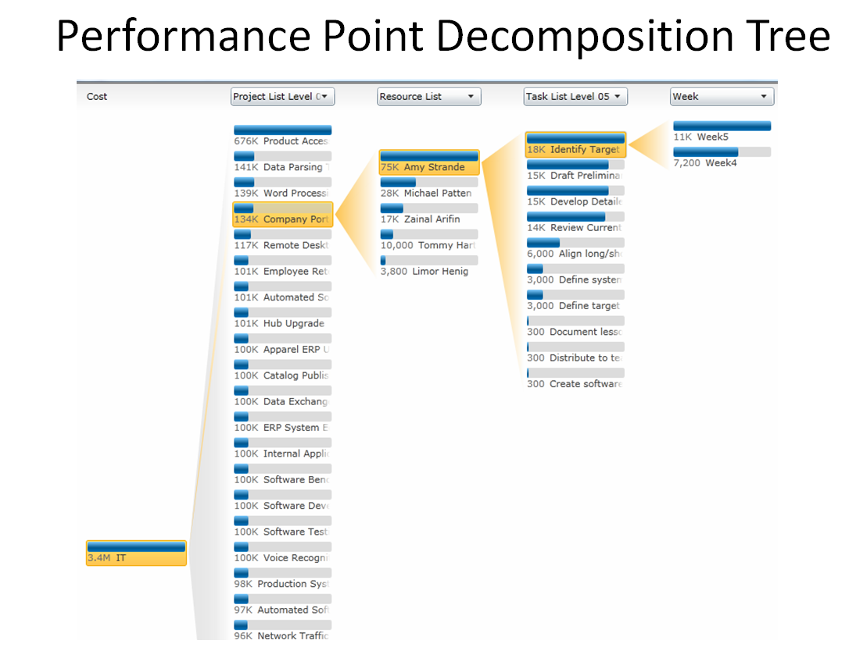Advisicon will help you setup and ensure you have good reporting capabilities that not only can come from Project or Project server, but can be applied to any data within the company and driven to SharePoint for collaboration and reporting portal.

**Advisicon Summary:**

In short Advisicon is not just a technology expert, but we have 20+ years of project, program, portfolio and PMO experience. We know how to build or use tools, but a tool almost worthless without a good process and methodology to reinforce what that tool is automating or tracking.

Advisicon works with our customers to help them to use and leverage the technology at the right level (not necessarily even all) and this is designed to support the adoption and integration of PM best practices alongside so that our customer get to Analytics and ROI quickly and the tools and processes are sustainable and last.

Everyone does projects and everyone uses tools, but there are very few who use both well together. That is our sweet spot and where we help our customers avoid un-necessary processes, or work that doesn’t meet the end strategic goal.

***Essentially we help our customers “Build and Automate a Project Management Culture” with processes, methodology, training and technology.***